

Foodie corner

Food and beverages influenced by our breathtakingly unique city. On our food tours, learn how to shop for Zambian food safely from the local market or take a Zambian food cooking class.

Now that you have rested, you will surely want to experience Dinner in Lusaka City. Lusakans are food lovers and restaurants in the city are endless.

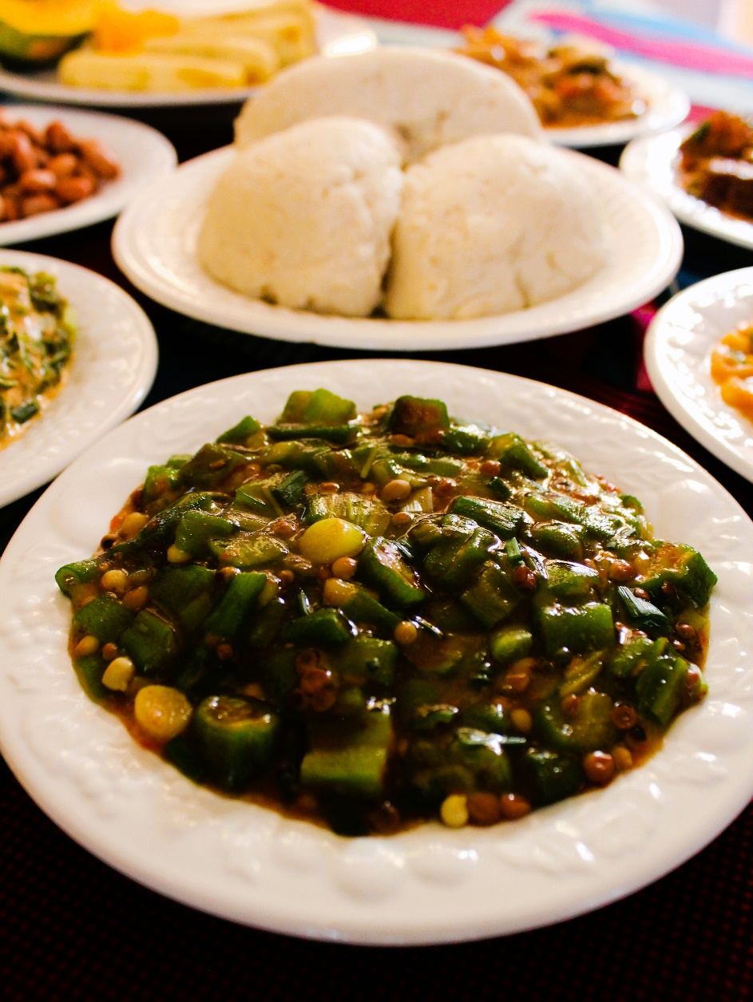

Here is a sample list of Lusaka Restaurants:

Lusaka City is generally peaceful, so be comfortable and enjoy your nightlife while having your vacation

1. Tikka House Restaurant

Excellent customer service and a wide selection of dishes on the menu.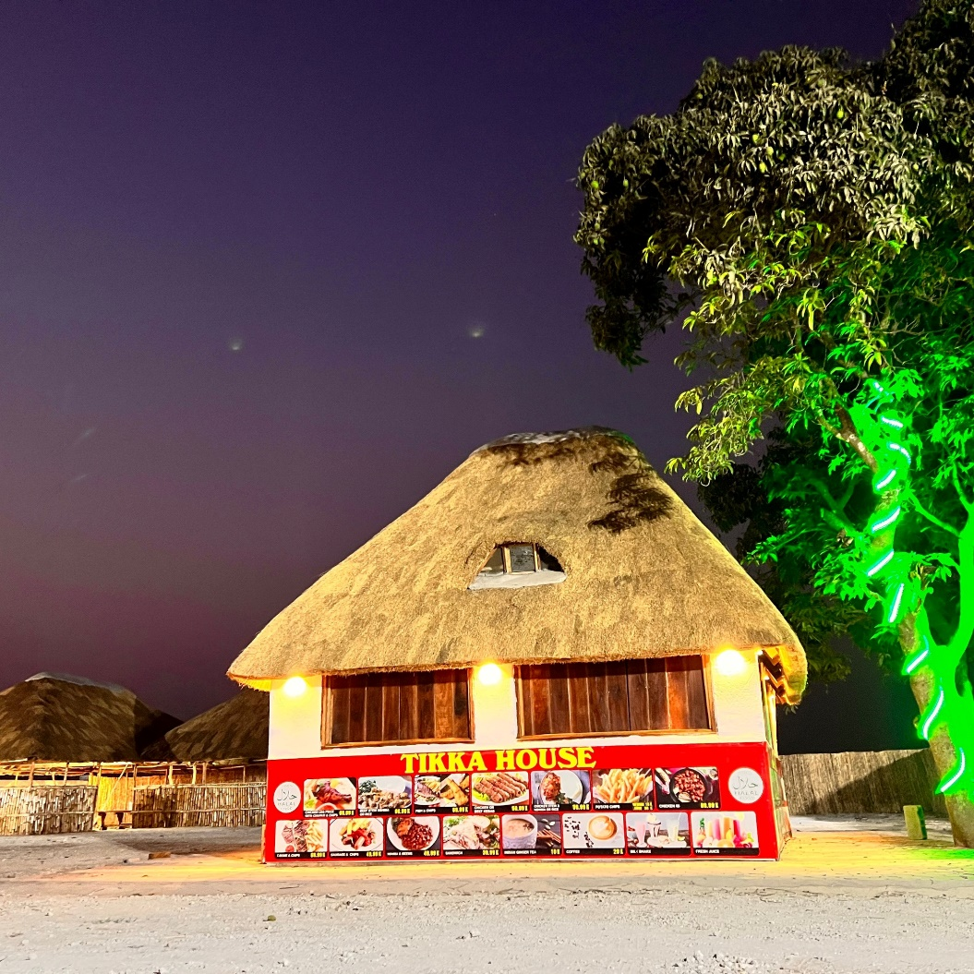

1. 3 Trees Restaurant

A family styled restaurant offering a range of food from all over the world.

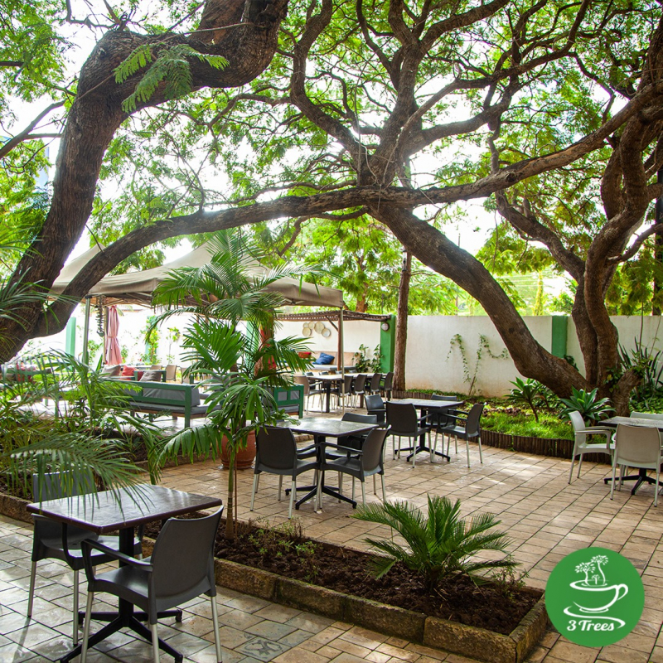

You can have your coffee or taste various cakes and pastries.

1. Mphoto Yathu

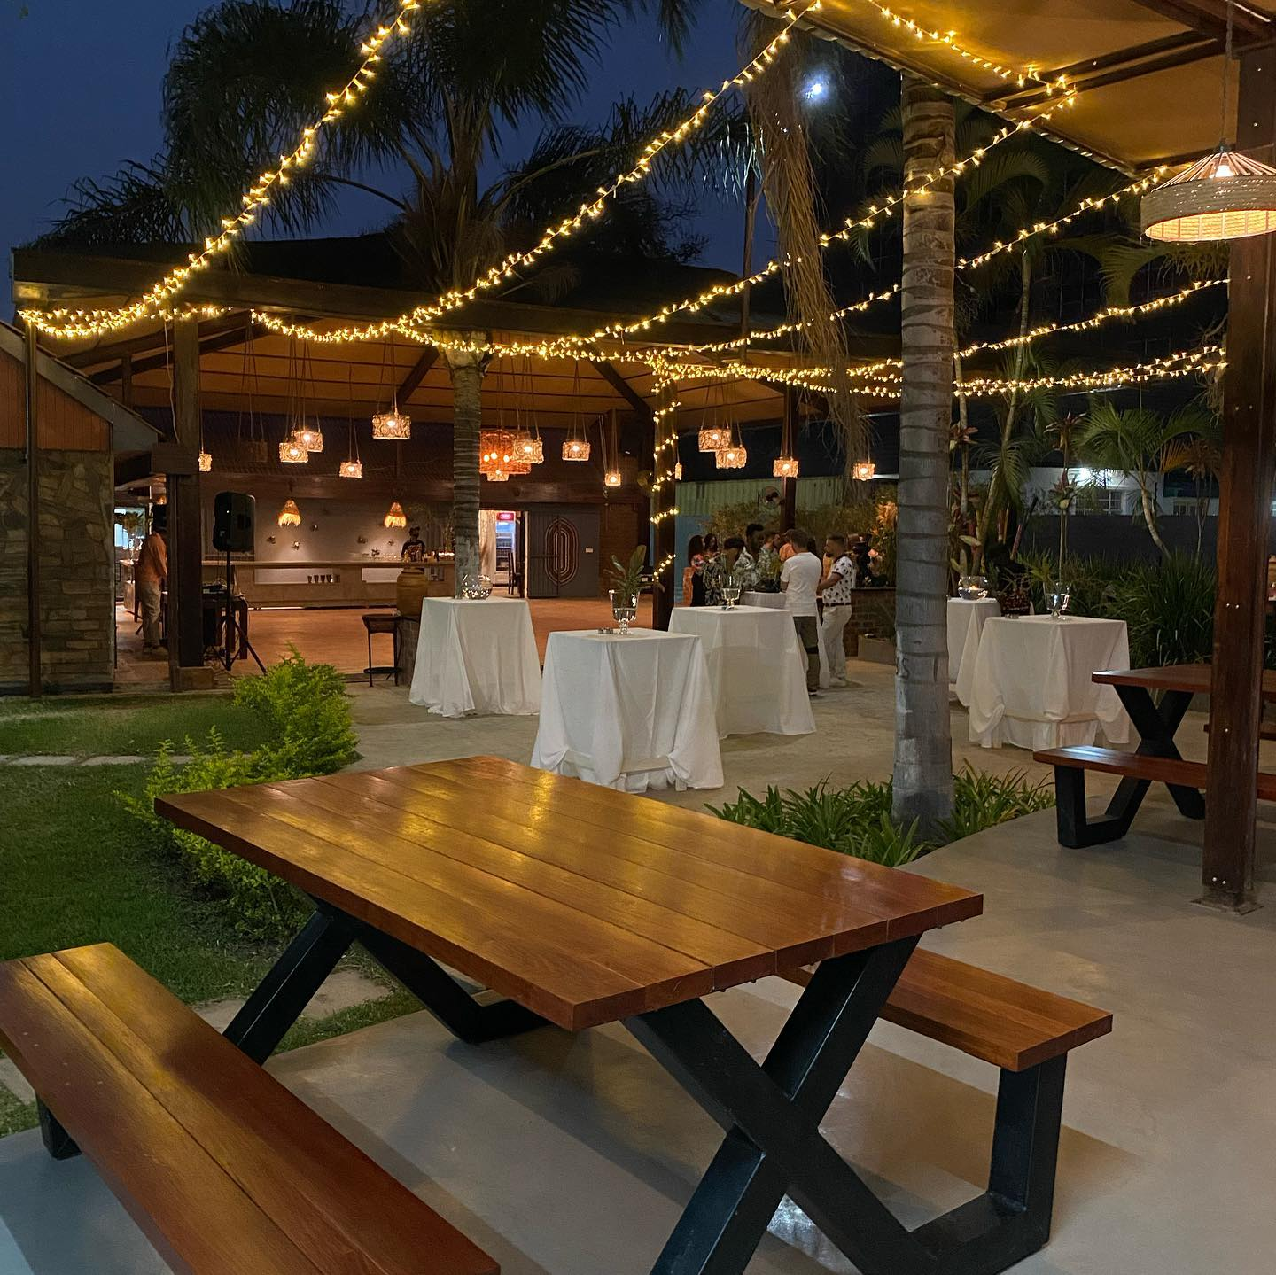

For your dinner, depending on where you are located, you can pick from a variety of restaurants along the area. try some seafood at the Foxdale Fun Park, you might want to try the Angoni grill with the salsa dancers of Lusaka. You might also want to try the Naija Chops restaurant near Centro Mall.

The nearest ‘food sensitive’ restaurant from Manda Hill is the Neelkanth Sarovar Hotel, right behind it. Others include Veganic, the Mocha Puddle and Habeez healthy Food café.

