About

MWAISENI, [ GREETINGS!] FROM THE SOUTHERN LIGHT TOURS TEAM

**The Southern Light Tours journey**

Every journey starts with one step, and ours wasn't any different in 2004 when we embarked on a journey from two-man band to a registered enterprise.

Travelling was part of our home training and we had many trips around Zambia, including vacations to Namibia and Botswana. Six years in South Africa led to the consolidation of this business that took place in Cape Town 2019 .

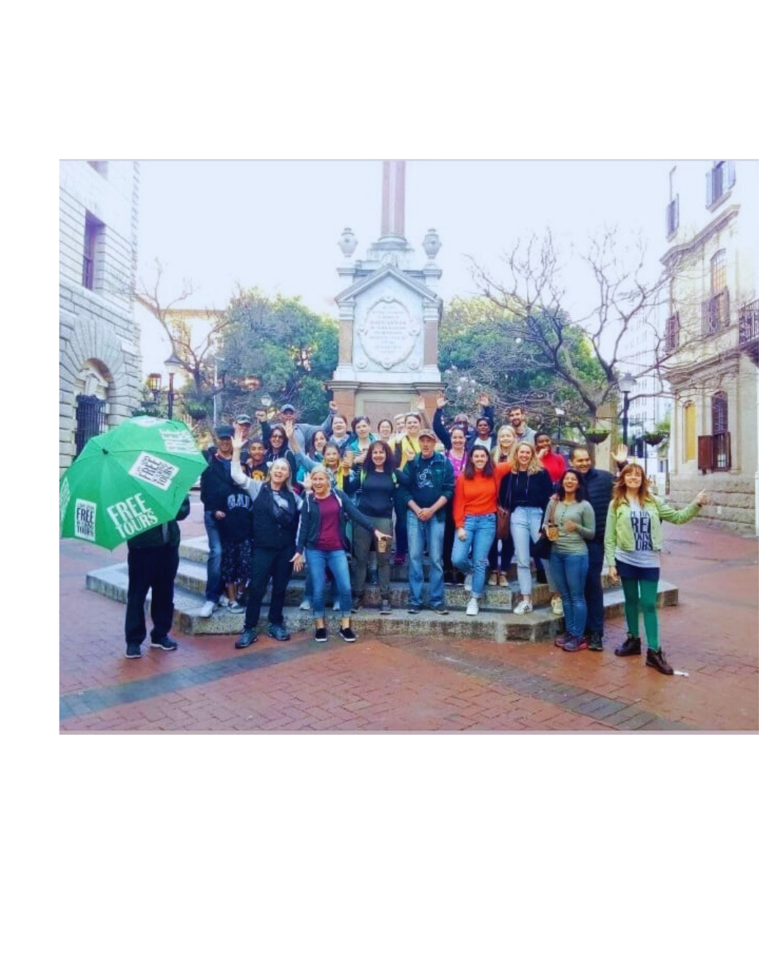

S.L Tours launched in the ‘land of work and joy’ during the Christmas season with a strong desire to provide genuine travel experiences, a great deal of perseverance, and—most importantly—a little bit of good fortune.

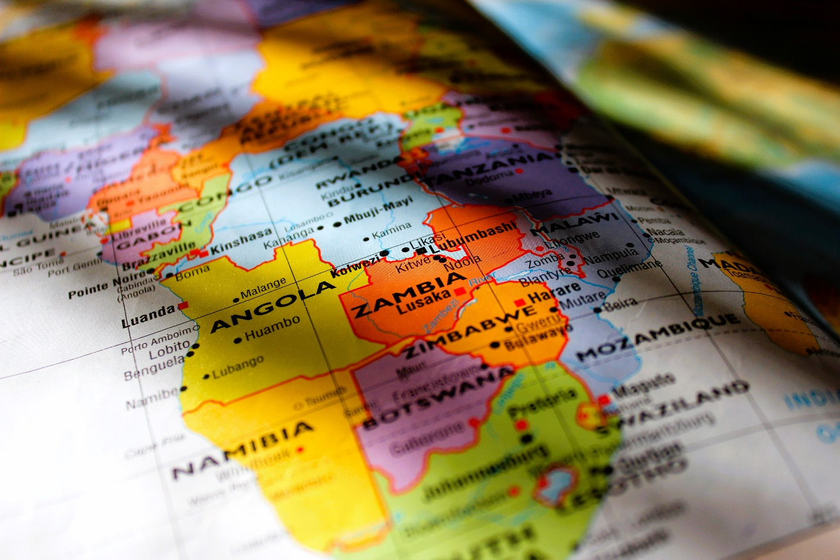

We've managed to grow into a medium-sized international business with our headquarters located in Lusaka, Zambia, and aim to open more offices in Kampala, Uganda, and Cape Town, South Africa, as well as a presence in Lagos, Nigeria.

We at S.L Tours are dedicated to providing genuine and approachable cultural experiences right in the center of our locations as we embark on a brand-new and exciting entry phase.

**Our vision**

To encourage locals to go on tours and local travel and appreciate their country. Our tours promote local businesses at a grassroots level through our sustainable travel practices.

Our tour leaders are passionate about sharing their nation with you.

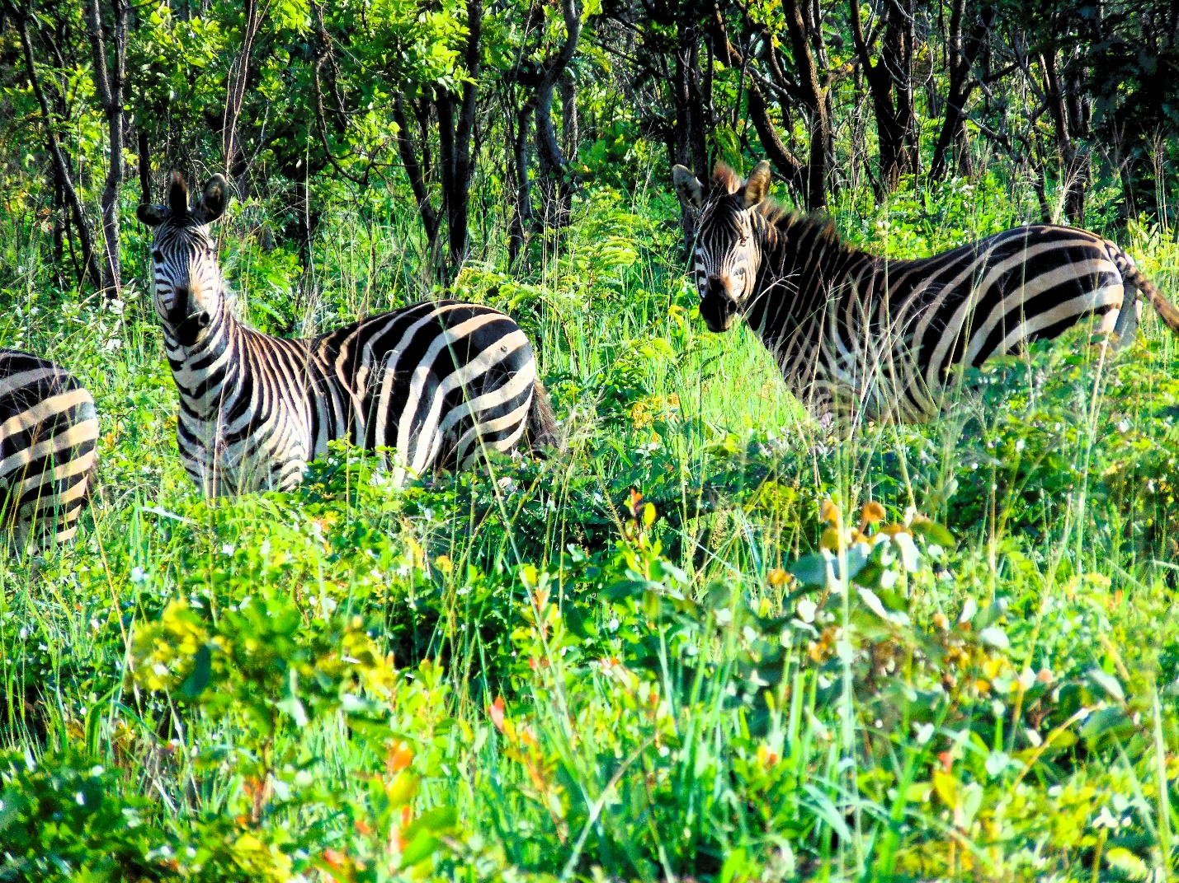

Above all, we're here to provide you with an amazing and memorable vacation since we understand how valuable time is and how traveling can help us escape the ordinary.

Greetings on your vacation. Support tours by locals!